Micro controllers les 3

1x Buzzer

1x Arduino

1x Rood LED lampje

1x Groen LED lampje

1x Schakelaar

1x breadboard

2x 100 Ohm resistor

6x kabels (2 female to mle)

1x oplaadkabel

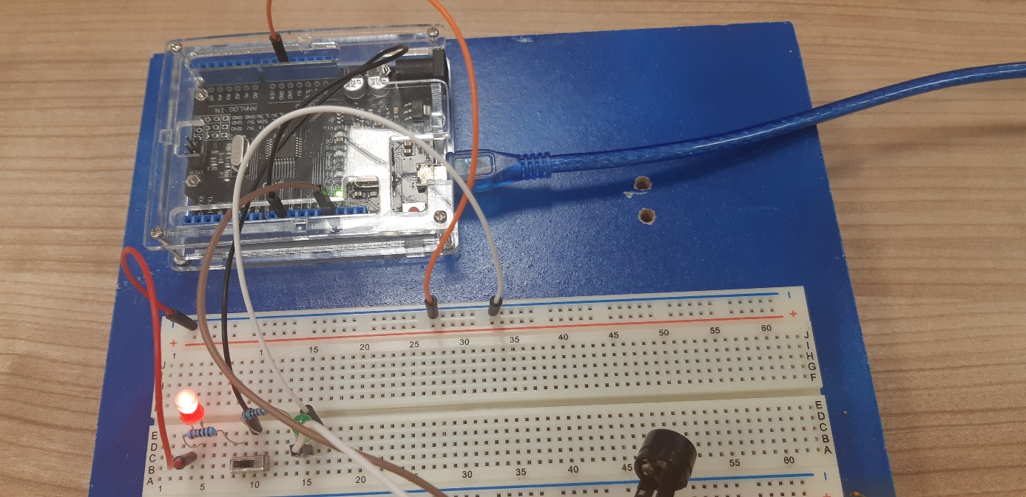

const int buzzer = 9; //buzzer to arduino pin 9

// put your setup code here, to run once:

void setup (){

pinMode(buzzer, OUTPUT); //Set buzzer - pin 9 as an output

}

void loop() {

// put your main code here, to run repeatedly:

tone(buzzer, 1000); // Send 1KHZ sound signal...

delay(100); // ...for 1 sec

tone(buzzer, 500); // Send 1KHZ sound signal...

delay(10); // ...for 1 sec

tone(buzzer, 750); // Send 1KHZ sound signal...

delay(100) // ...for 1 sec

;tone(buzzer, 250); // Send 1KHZ sound signal...

delay(10); // ...for 1 sec

tone(buzzer, 750); // Send 1KHZ sound signal...

delay(100) // ...for 1 sec

;tone(buzzer, 250); // Send 1KHZ sound signal...

delay(10); // ...for 1 sec

tone(buzzer, 1000); // Send 1KHZ sound signal...

delay(100); // ...for 1 sec

tone(buzzer, 400); // Send 1KHZ sound signal...

delay(10); // ...for 1 sec

tone(buzzer, 650); // Send 1KHZ sound signal...

delay(100) // ...for 1 sec

;tone(buzzer, 150); // Send 1KHZ sound signal...

delay(10); // ...for 1 sec

tone(buzzer, 650); // Send 1KHZ sound signal...

delay(100) // ...for 1 sec

;tone(buzzer, 150); // Send 1KHZ sound signal...

delay(10); // ...for 1 sec

tone(buzzer, 1000); // Send 1KHZ sound signal...

delay(100); // ...for 1 sec

tone(buzzer, 400); // Send 1KHZ sound signal...

delay(10); // ...for 1 sec

tone(buzzer, 650); // Send 1KHZ sound signal...

delay(100) // ...for 1 sec

;tone(buzzer, 150); // Send 1KHZ sound signal...

delay(10); // ...for 1 sec

tone(buzzer, 650); // Send 1KHZ sound signal...

delay(100) // ...for 1 sec

;tone(buzzer, 150); // Send 1KHZ sound signal...

delay(10); // ...for 1 sec

tone(buzzer, 1000); // Send 1KHZ sound signal...

delay(100); // ...for 1 sec

tone(buzzer, 500); // Send 1KHZ sound signal...

delay(10); // ...for 1 sec

tone(buzzer, 750); // Send 1KHZ sound signal...

delay(100) // ...for 1 sec

;tone(buzzer, 250); // Send 1KHZ sound signal...

delay(10); // ...for 1 sec

tone(buzzer, 750); // Send 1KHZ sound signal...

delay(100) // ...for 1 sec

;tone(buzzer, 250); // Send 1KHZ sound signal...

delay(10); // ...for 1 sec

;}